TITLE OF THE DOCUMENT and CONTENTS:
MINISTRY OF FINANCE

DEPARTMENT FOR FINANCIAL INSPECTION IN THE PUBLIC SECTOR
AND COORDINATION FOR COMBATING FRAUD AGAINST EU FUNDS

ANNUAL REPORT
on the Work of the Financial Inspection in the Public Sector in 2022

Skopje, March 2023

INTRODUCTION
Pursuant to Article 53 of the Law on Financial Inspection in the Public Sector (“Official Gazette of the Republic of North Macedonia”, no. 19/23), Ministry of Finance submits to the Government of the Republic of North Macedonia an annual report on the work of the financial inspection in the public sector for the previous year by 31st March in the current year at the latest.
The competence, the procedure for performing financial inspection and the organizational setup of the financial inspection in the public sector are regulated under the Law on Financial Inspection in the Public Sector.
Accordingly, the Report provides information on the following:
- organizational setup of the Department for Financial Inspection in the Public Sector and Coordination for Combating Fraud against EU Funds within the Ministry of Finance;
- work of the financial inspection in the public sector in 2022 and
- undertaken measures aimed at improving the institutional setup of the financial inspection in the public sector function.

- Organizational Setup of the Department for Financial Inspection in the Public Sector and Coordination for Combating Fraud against EU Funds within the Ministry of Finance
Pursuant to the Law on Financial Inspection in the Public Sector, financial inspection activities are performed by the Department for Financial Inspection in the Public Sector (hereinafter referred to as: Department), as a separate internal organization unit within the Ministry of Finance. Chief Financial Inspector (hereinafter referred to as: Chief Inspector) manages the Department and is directly responsible to the Minister of Finance.
The Department has been operational since 2015. Pursuant to the Rulebook on Modifications and Amendments to the Systematization Act of the Ministry of Finance, adopted by the Minister of Finance on 5th December 2018, the Department was renamed Department for Financial Inspection in the Public Sector and Coordination for Combating Fraud against EU Funds, and it comprises two Units:
- Unit for Financial Inspection of Entities at Central and Local Level, envisaging 7 working posts: Head of Unit - senior inspector, two advisers - inspectors, two senior associates - junior inspectors and two junior associates, and
- EU Anti-Fraud Coordination Unit (AFCOS), envisaging 5 working posts: Head of Unit, adviser, senior associate, associate and junior associate, in charge of coordinating the administrative and the operational tasks and duties and activities and proposing changes to the national legislation, all to the end of protecting the EU financial interests.
Unit for Financial Inspection of Entities at Central and Local Level performs tasks and duties related to financial inspection. Financial inspection is carried out at state Budget users, the Funds, the municipalities and the City of Skopje, agencies and other institutions established by law, public enterprises, public institutions and other legal entities owned by the state or the municipalities and the City of Skopje, or whereat the state or the municipalities and the City of Skopje are shareholders, beneficiaries of EU funds, non-profit organizations and other legal entities and individuals solely for the part of the public funds or guarantees received.
- Information on the Work of the Financial Inspection in the Public Sector in 2022
Financial inspection is an ex-post activity to control the regularity of the transaction and other activities in the filed of financial management and control carried out at the entities subject to inspection. Goal of the financial inspection is to protect the financial interests of the public sector entities against significantly poor financial management, frauds and corruption at the public sector entities pursuant to the Law on Financial Inspection in the Public Sector and the special regulations stipulating the competence for performing financial inspection.
In 2022, financial inspection was performed in line with the Law on Financial Inspection in the Public Sector (“Official Gazette of the Republic of Macedonia”, nos. 82/13, 43/14, 153/15, 164/18 and “Official Gazette of the Republic of North Macedonia”, no. 122/21). Financial inspection procedure is initiated on the basis of: a request substantiated with evidence, information or report filed by legal entities or natural persons; notification on exceeding the legally prescribed deadlines for settlement of liabilities; notification on or records of violation of the procedures for financial management and control; financial management and control report; internal audit report, i.e. report of the State Audit Office; request submitted by the Government of the Republic of North Macedonia; request submitted by a head or an employee with a public sector entity; request submitted by the Public Prosecutor’s Office of the Republic of North Macedonia; request submitted by the European Anti-Fraud Office (OLAF) and authorization granted by the Chief Inspector and upon order by the Minister of Finance, after learning of a reasonable suspicion of significantly poor financial management, frauds and corruption.
Chief Inspector initiates the procedure for financial inspection in the public sector by issuing an authorization to the financial inspectors who perform financial inspection, prepare report on the performed financial inspection, together with findings substantiated with relevant evidence and draft measures, monitor the implementation of the measures by the entity subject to supervision, conduct a settlement procedure by issuing misdemeanor payment order to the entity subject to supervision and the responsible person at the entity subject to supervision and submit motion for initiation of a misdemeanor procedure to the competent court in case of an established misdemeanor.
In general, filed reports are acted upon on the basis of the established risk. Supervision over the implementation of the provisions of the Law on Financial Discipline is an exception to this rule, when the Financial Inspection is obliged to act and conduct control within 30 days from receiving the notification. As a result of this legally prescribed obligation, priority when acting upon is given to cases in the field of financial discipline.
Total of 11,310 reports were filed to the Financial Inspection in the period 2014 - 2022. In the course of 2022, 2,865 out of the total number of reports were filed to the Department, i.e. 239 reports in average each month. Thereby, 17 out of the total number of reports filed in 2022 tackled larger number of public sector entities, i.e. one report in average tackled 142 public sector entities. The Department recorded them as separate reports by entity.
In the course of 2022, the Financial Inspection acted upon as follows:
- 390 authorizations for initiating procedure for financial inspection in the public sector were issued;
- minutes of performed inspection supervision/reports on performed financial inspection at public sector entities were compiled on the basis of 304 reports;
- no misdemeanor was detected in the financial inspection procedure initiated on the basis of 195 reports, hence, acts were prepared to cease the inspection supervision procedure;
- 91 decisions were prepared to reject the report filed, pursuant to law, due to holding no jurisdiction or not eliminating the deficiencies in an incomplete or unclear submission by an authorized reporting party;
- 5 decisions were prepared to cease the financial inspection procedure, pursuant to law, due to the reporting party having withdrawn the report;
- 33 notifications were prepared for holding no jurisdiction by the Financial Inspection to act, pursuant to law;
- 18 minutes were compiled for detected misdemeanor prescribed in the Law on Financial Inspection in the Public Sector;
- settlement procedures were carried out by issuing 116 misdemeanor payment orders, pronouncing fines in the total amount of EUR 102,100 in denar equivalent. Settlement procedures for 44 of the misdemeanor payment orders were successfully completed, i.e. perpetrators of the misdemeanor paid half of the amounts of the pronounced fines within the legally prescribed deadline of 8 days upon receiving the misdemeanor payment orders, i.e. fines in the amount of EUR 8,375 in denar equivalent were collected. As regards the settlement procedures in which the fines were not paid within the legally prescribed deadline, the financial inspection submitted motions for initiating misdemeanor procedure before the competent courts.
- 20 motions for initiating misdemeanor procedure before the competent courts were submitted; Thereby, courts acted upon 5 of the motions in 2022, i.e. they reached 5 decisions pronouncing 4 admonitions, pronounced 3 fines in the total amount of EUR 500 in denar equivalent, and 1 motion for initiating a misdemeanor procedure was returned in order to initiate a settlement procedure. The Financial Inspection filed an appeal to a higher court against the decision to return the motion for initiating misdemeanor procedure in order to initiate a settlement procedure, and the court procedure is ongoing.
Total of 28 measures were pronounced within the reports on performed financial inspection, pursuant to the Law on Financial Inspection in the Public Sector. 19 out of them pertained to returning funds to the Budget of the Republic of North Macedonia, totaling Denar 36,830,647.00, Denar 16,506,201.00 out of which was returned to the state Budget by 31st December 2022 inclusive. Entities subject to financial inspection acted upon 5 measures within the deadlines set in the reports and upon 3 measures after the deadlines set in the reports, while with respect to the other 20 measures, they did not act and motions for initiation of a misdemeanor procedure before the competent court were submitted therefore.
- 4 minutes produced from performed inspection supervision/reports on performed financial inspection on the basis of 8 reports were submitted to the Basic Public Prosecutor’s Office, since they included allegations falling within its competence. Thereby, competent prosecutor undertook pre-investigative actions on the basis of minutes from performed inspection supervision and report on performed financial inspection by submitting orders and requests pursuant to the Criminal Procedure Law, while as regards the other 2 reports from performed financial inspection, no action has been taken yet.
- Financial inspection procedure is ongoing for 222 reports filed.
With respect to the data shown in points 2, 3, 7, 8, 9, 10, 11 and 12, it should be indicated that they are generated from the financial inspection procedures conducted in 2022, as well as the ones conducted in 2021.

Figure 1 - Comparative Overview of Issued and Paid Misdemeanor Orders in 2021 and 2022
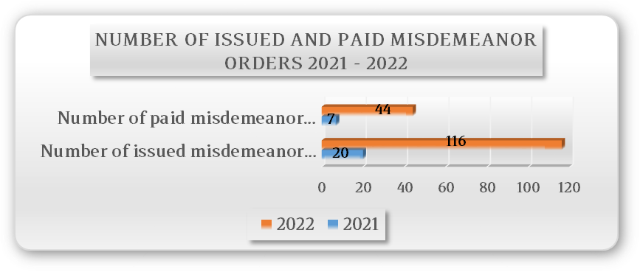
Figure 1 gives a comparative overview of the number of issued misdemeanor payment orders in 2022 compared to 2021, and the number of issued misdemeanor payment orders in 2022 compared to 2021, when the perpetrator paid the fine. As shown, number of issued misdemeanor payment orders and number of misdemeanor payment orders when the perpetrator paid the fine in 2022, compared to 2021, significantly increased. Number of misdemeanor payment orders issued in 2022 compared to the number of misdemeanor payment orders issued in 2021 increased by 480%, while number of misdemeanor payment orders issued in 2022, with the perpetrator having paid the fine, compared to the ones in 2021, surged by 529%.

Figure 2 - Comparative Overview of the Amount of Fines Pronounced and Paid under Settlement Procedures in 2021 and 2022
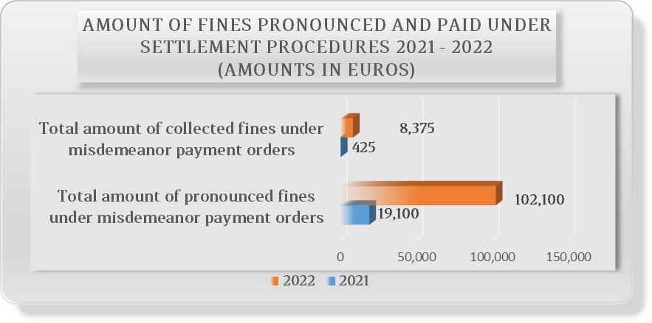
Figure 2 gives a comparative overview of the amount of fines pronounced and paid under settlement procedures in 2022 compared to 2021, clearly indicating the positive trend in 2022. Amount of pronounced fines under settlement procedures in 2022 compared to the amount of pronounced fines under settlement procedures in 2021 increased by 435%, while amount of paid fines under settlement procedures in 2022 compared to 2021 surged by 1,871%.
On the basis of motions for initiation of misdemeanor procedures, competent courts adopted total of 8 decisions in 2022. Thereby, 6 admonitions were pronounced under 4 decisions, 3 fines in the total amount of EUR 500 in denar equivalent were pronounced under 2 decisions, 1 decision pertained to returning 1 motion for initiating a misdemeanor procedure in order to initiate a settlement procedure and 1 decision pertained to rejecting the motion for initiating misdemeanor procedures. The Financial Inspection filed an appeal to a higher court against the decision to return the motion for initiating misdemeanor procedure in order to initiate a settlement procedure and the decision to reject the motion for initiating a misdemeanor procedure, and the court procedures are ongoing.
In the course of 2022, within the performed financial inspections, supervision was carried out over the adherence to the provisions in the Law on Financial Inspection in the Public Sector, the Law on Financial Assistance to Local Government Units and Budget Users Established by the Local Government Units for the Purpose of Financing Arrears, the Law on Public Procurement, the Law on State Examination Center, the Law on Training and Exam for Director of Primary School, Secondary School, Dormitory and Open Citizens University for Lifelong Learning, the PIFC Law and respective bylaws, the Law on Financing Local Government Units and respective bylaws, the Law on Reporting and Recording Liabilities and the Law on Financial Discipline.

- Undertaken Measures Aimed at Improving the Institutional Setup of the Financial Inspection in the Public Sector Function
Under the Public Financial Management Reform Program “SMART PUBLIC FINANCES” 2022 - 2025, Pillar VI - Public Internal Financial Control, new Priority 3 - Financial Inspection is envisaged, aimed at professional development and strengthening the financial inspection function as basis for increasing the quality of financial control in order to protect the public financial interests.
This priority’s objective will be achieved through two measures, as follows:
- strengthening the institutional basis of the financial inspection function, incorporating three activities for its implementation: improving the legal framework, introducing a system of performance-based annual remuneration for financial inspectors and improved methodologies and systematization (increasing the value added of the financial inspection function) and
- strengthening the financial inspection human resource capacity, to be achieved through two activities: designing a concept for obtaining a license for financial inspector and preparing an annual training program for financial inspectors.
In 2022, measures were undertaken within the planned activities aimed at systemic strengthening of the financial inspection in the public sector, all to the end of ensuring a responsible, accountable, successful and transparent public financial management in support of implementing managerial accountability.
With respect to strengthening the financial inspection human resource capacity, one person was employed. Under the new Rulebook on Internal Organizational Setup and Operations of the Ministry of Finance, Financial Inspection Unit is divided in two new units for financial inspection of entities at central level and at local level. Total of 14 working positions are envisaged in the two Units, among which the positions of Chief Inspector and Assistant Chief Inspector.
Under the respective Rulebook, Public Finance Academy Department is established within the Ministry of Finance, providing for continuous professional development and vocational training of financial inspectors in performing financial inspection, as well as obtaining license for financial inspector and conducting an exam for obtaining a license for financial inspector.
As per the measure aimed at improving the regulations on financial inspection in the public sector, Draft Law on Financial Inspection was prepared with the support of IPA Twinning Project “Strengthening Budget Planning, Execution and Internal Control Functions”. Under an excerpt from the Draft Minutes of the 48th session of the Government of the Republic of North Macedonia held on 25th May 2022, no. 41-3058/1, Draft Law was submitted to the Parliament of the Republic of North Macedonia.
In the course of 2022, activities were undertaken for the purpose of preparing internal operational procedures of the Department for Financial Inspection in the Public Sector and Coordination for Combating Fraud against EU Funds and carrying out training in applying the new methodological tools, whereby, with the support of the IPA Twinning Project, part of both the draft methodological tools and the internal procedures was prepared.
2021 - 2022 Training Program for the Employees in the Financial Inspection Department was prepared with the support of the IPA Twinning Project “Strengthening Budget Planning, Execution and Internal Control Functions”, so as for the Department’s employees to acquire the necessary expertise and skills to identify, detect and, later on, act upon detected irregularities or suspicion of a criminal deed in budget management, thus contributing to strengthened financial discipline and safeguarding of the national financial interests. Following activities were undertaken:
- workshop was organized on determining the priorities of financial inspection on the basis of set criteria and preparatory activities for performing financial inspection, and
- study visit to Zagreb, Croatia, was organized.
Other methodological tools, internal procedures, as well as bylaws and internal acts, will be prepared with the support of IPA Twinning Project experts, as per the new Law on Financial Inspection in the Public Sector, under the dynamics set with the IPA Project and in line with the legally prescribed deadlines for their adoption.

With respect to the inspection supervision procedures in terms of adherence to the provisions in the Law on Financial Discipline (“Official Gazette of the Republic of Macedonia”, nos. 187/13, 201/14, 215/15 and “Official Gazette of the Republic of North Macedonia”, nos. 124/19 and 122/21), minutes are compiled of the performed inspection supervision, while regarding other financial inspection procedures, report on performed financial inspection is compiled pursuant to the Law on Financial Inspection in the Public Sector (“Official Gazette of the Republic of Macedonia”, nos. 82/13, 43/14, 153/15, 164/18 and “Official Gazette of the Republic of North Macedonia”, no. 122/21).

