TITLE OF THE DOCUMENT and CONTENTS:

MINISTRY OF FINANCE

DEPARTMENT FOR FINANCIAL INSPECTION IN THE PUBLIC SECTOR
AND COORDINATION FOR COMBATING FRAUD AGAINST EU FUNDS

ANNUAL REPORT

on the Work of the Financial Inspection in the Public Sector in 2023

Skopje, March 2024
INTRODUCTION
Pursuant to Article 53 of the Law on Financial Inspection in the Public Sector (*) (“Official Gazette of the Republic of North Macedonia“, no. 19/23), Ministry of Finance submits to the Government of the Republic of North Macedonia an annual report on the work of the financial inspection in the public sector for the previous year by 31st March in the current year at the latest.
The competence, the procedure for performing financial inspection and the organizational setup of the financial inspection in the public sector were previously regulated under the Law on Financial Inspection in the Public Sector (“Official Gazette of the Republic of Macedonia”, no. 82/13, 43/14, 153/15 and 164/18 and “Official Gazette of the Republic of North Macedonia“, no. 122/21), and starting February 2023, the new Law on Financial Inspection in the Public Sector entered into force (*) (“Official Gazette of the Republic of North Macedonia”, no. 19/23), being harmonized with the Regulation (EU) No 910/2014 of the European Parliament and of the Council of 23 July 2014 on electronic identification and trust services for electronic transactions in the internal market and repealing Directive 1999/93/EC.
Accordingly, the Report provides information on the following:
- organizational setup of the Department for Financial Inspection in the Public Sector and Coordination for Combating Fraud against EU Funds within the Ministry of Finance.
- work of the financial inspection in the public sector in 2023 and
- undertaken measures aimed at improving the institutional setup of the financial inspection in the public sector function.

I. Organizational Setup of the Department for Financial Inspection in the Public Sector and Coordination for Combating Fraud against EU Funds within the Ministry of Finance
Pursuant to the Law on Financial Inspection in the Public Sector (*), financial inspection activities are performed by the Department for Financial Inspection in the Public Sector (hereinafter referred to as: Department), as a separate internal organization unit within the Ministry of Finance. Chief Financial Inspector (hereinafter: referred to as: Chief Inspector) manages the Department and is directly responsible to the Minister of Finance.
The Department has been operational since 2015. Pursuant to the Rulebook on Modifications and Amendments to the Systematization Act of the Ministry of Finance, adopted by the Minister of Finance on 5th December 2018, the Department was renamed Department for Financial Inspection in the Public Sector and Coordination for Combating Fraud against EU Funds, and it comprises two Units: Unit for Financial Inspection of Entities at Central and Local Level, in charge of performing tasks and duties related to financial inspection and EU Anti-Fraud Coordination Unit (AFCOS) in charge of coordinating the administrative and the operational tasks and duties and activities and proposing changes to the national legislation, all to the end of protecting the EU financial interests.
As per the new Rulebook on Systematization of Working Posts in the Ministry of Finance, adopted by Minister of Finance at the end of 2022, the Unit for Financial Inspection of Entities at Central and Local Level, is divided into two separate Units: Unit for Financial Inspection of Entities at Central Level and Unit for Financial Inspection of Entities at Local Level.
In addition to the Chief Inspector, in line with the act on systematization of the working posts in the Ministry, the working post for Assistant Head of Department - Assistant Chief Inspector is envisaged, which is vacant, and as of the end of 2022, the Department has been operating with three Units, as follows:
a) Unit for Financial Inspection of Entities at Central Level, envisaging 6 working posts: 1 Head of Unit – Senior Inspector, 3 Advisors – Inspectors, 1 Senior Associate – Junior Inspector and 1 Junior Associate.
a) Unit for Financial Inspection of Entities at Local Level, envisaging 7 working posts: 1 Head of Unit - Senior Inspector, 3 Advisors – Inspectors, 1 Senior Associate – Junior Inspector, 1 Junior Associate and 1 officer.
c) EU Anti-Fraud Coordination Unit (AFCOS), envisaging 6 working posts: 1 Head of Unit, 3 Advisors, 1 Associate and 1 Junior Associate.
In the period 2019 – August 2023, Financial Inspection incorporated only 1 Chief Inspector, 2 Advisors – Inspectors, 2 Senior Associates – Junior Inspectors and 2 Junior Associates.
In the month of August 2023, promotion procedures were implemented, as follows:
- 2 Advisors – Inspectors were promoted in Heads of Unis
- 2 Senior Associates – Junior Inspectors were promoted to Advisors – Inspectors.
At the end of December 2023 procedure was commenced, pertaining to the promotion of 1 Junior Associate in Senior Associate – Junior Inspector.
Financial inspection is carried out at state Budget users, the Funds, the municipalities and the City of Skopje, agencies and other institutions established by law, public enterprises, public institutions and other legal entities owned by the state or the municipalities and the City of Skopje, or whereat the state or the municipalities and the City of Skopje are shareholders, beneficiaries of EU funds, non-profit organizations and other legal entities and individuals solely for the part of the public funds or guarantees received (hereinafter referred to as: financial inspection entities).

II. Work of the Financial Inspection in the Public Sector in 2023
Financial Inspection performs inspection supervision over the legitimacy, efficient and accountable usage of budget funds, resources under the EU Funds, as well as funds from other public sources, regardless of whether they are revenue, cost, expenditure, refund of funds, receivables, liabilities and capital at financial inspection entities. Financial inspection is aimed at protecting public financial interests as regard the financial management of state budget funds, budgets of local government units and budgets of other public sources, as well as resources under the EU funds, by determining the legitimacy and their efficient and responsible use in line with the respective regulations, stipulating the competence for performing financial inspection.
In 2023, financial inspection was performed pursuant to the Law on Financial Inspection in the Public Sector (*) (“Official Gazette of the Republic of North Macedonia”, no. 19/23). Launch of financial inspection is based upon the reports filed in paper by individuals, heads or employees in the financial inspection entities and legal entities substantiated by evidence and/or fundings for existence of grounded suspicion of perpetrated irregularity, shortage and/or suspicion of a criminal deed in the field of financial management of the public funds and the resources under the EU Funds, as well as upon report filed by EU Anti-Fraud Coordination Unit (AFCOS), acting upon request by European Anti-Fraud Office (OLAF - Office Europeen de Lutte Anti-Fraude) at financial inspection entities.
Financial inspections commenced until the entry into force of the new Law on Financial Inspection in the Public Sector (*) (“Official Gazette of the Republic of North Macedonia”, no.19/23) , were completed as per the provisions referred to in the new Law on Financial Inspection in the Public Sector (“Official Gazette of the Republic of Macedonia”, nos. 82/13, 43/14, 153/15, 164/18 and “Official Gazette of the Republic of North Macedonia”, no. 122/21).
Chief Inspector initiates the financial inspection procedure in the public sector by issuing authorization of the financial inspectors for performing financial inspection upon submitted financial inspection report, as per its priority, in line with the criteria for determining the report priority.
In the period 2014 - 2023 inclusive, total of 13,464 reports were filed to the Financial Inspection, out of which 2,054 reports fere filed to the Department during 2023.
In the course of 2023, the Financial Inspection acted upon as follows:
- Authorizations for initiating procedure for financial inspection in the public sector were issued on the basis of 499 filed financial inspection reports.
- minutes of performed inspection supervision/reports on performed financial inspection/final minutes on performed financial inspection at public sector entities were compiled on the basis of 304 reports;
- no misdemeanor was detected in the financial inspection procedure initiated on the basis of 82 reports, hence, acts were prepared to cease the inspection supervision procedure;
- 156 decisions were prepared to reject the report filed, pursuant to law, due to holding no jurisdiction, having no substantiated evidence and/or findings for existence of grounded suspicion of perpetrated irregularity, deficiency and/or suspicion of crime, pertaining to the financial management of public funds, as well as resources under the EU Funds at the entities, not eliminating deficiencies or incomplete or unclear submission by authorized reporting entity, filing of report by authorized reporting entity upon the expiry of the legally set deadline and decisions for terminating the financial inspection procedure pursuant to law due to the withdrawal of the report by the authorized reporting entity.
- 6 notifications were submitted to the competent authority pursuant to law.
- settlement procedures were carried out by issuing 333 misdemeanor payment orders, pronouncing fines in the total amount of Denar 9,363,375.00.
- Under the settlement procedures, which were successfully completed, i.e. perpetrators of the misdemeanors paid half of the amounts of the pronounced fines within the legally prescribed deadline of 8 days upon receiving the misdemeanor payment orders, i.e. fines in the amount of Denar 1,028,086.00 were collected. As regards the settlement procedures, which were not completed successfully, the financial inspection submitted, pursuant to law, motions for initiating misdemeanor procedure before the competent courts,
- 125 motions for initiating misdemeanor procedure before the competent courts were submitted On the basis of 66 out of total submitted 125 motions, competent courts acted thereupon in the course of 2023, reaching the following decisions:
  - Upon 50 motions for initiating misdemeanor procedure, first-instance court reached decisions pronouncing 23 fines in the total amount of EUR 3,805 in denar equivalent. Financial inspection filed 19 appeals against some of these decisions before a higher court, due to the amount of the pronounced fine being below the minimum amount of the globe foreseen in the existing law, stipulating the misdemeanor. out of them 8 out of these appeals were accepted and higher courts reached merit-based decisions by pronouncing maximum amounts of globes for the perpetrators, foreseen under the laws, stipulating the misdemeanors, i.e. 8 pronounced fines in the total amount of EUR 8,500 in denar equivalent (Denar 522, 750.00). As for the other filed appeals, the court procedures are ongoing.
  - Upon 11 motions for initiating misdemeanor procedure, first-instance courts reached decisions pronouncing 13 admonitions against which, the financial inspection filed 11 appeals to higher court, due to the failure to meet the legal requirements for pronouncing misdemeanor sanction – admonition from the first-instance court. 9 out of these appeals were accepted and higher courts reached merit-based decisions by pronouncing maximum amounts of globes for the perpetrators, foreseen under the laws, stipulating the misdemeanors, i.e. 9 pronounced fines in the total amount of EUR 6,500 in denar equivalent (Denar (399,750.00). As for the other filed appeals, the court procedures are ongoing.
  - As for 6 motions for initiating misdemeanor procedure, the courts of first instance reached decisions to return the motions for the purpose of carrying out a settlement procedure
- Financial inspection has received decisions from the competent courts during 2023 upon 24 motions for initiating misdemeanor procedure before a competent court submitted in the previous years, as follows:
  - Upon 50 motions for initiating misdemeanor procedure, first-instance court reached decisions pronouncing 6 fines in the total amount of EUR 4,000 in denar equivalent (Denar (246,000.00). Financial Inspection filed an appeal to a higher court against 1 of these decisions, due to the amount of the pronounced fine, being below the minimum amount of fine foreseen in the existing law stipulating the misdemeanor, being rejected by the higher court and related to such decision of the higher court, preparation of proposal for filing motion for protection of legality is ongoing, which will be submitted to the Basic Public Prosecution’s Office.
  - Upon 6 motions for initiating misdemeanor procedure, first-instance court reached decisions pronouncing 7 admonitions. Against 6 of these decisions, the financial inspection filed appeals to higher court, due to the failure to meet the legal requirements for pronouncing misdemeanor sanction – admonition from the court of first instance. 2 out of these appeals were accepted and the higher court reached merit-based decisions by pronouncing maximum amounts of globes for the perpetrators, foreseen under the laws, stipulating the misdemeanors, i.e. pronounced 2 fines in the total amount of EUR 1,000 in denar equivalent (Denar 61,500.00), while 1 appeal was rejected by the high court due to untimely delivery. As for the other filed appeals, the court procedures are ongoing.
  - As for 9 motions for initiating misdemeanor procedure, the courts of first instance reached 9 decisions to return the motions for the purpose of carrying out a settlement procedure, against which the financial inspection filed appeals to higher court and there are ongoing court procedures.
  - As for 1 motion for initiating misdemeanor procedure, the court of first sale reached decision to reject motion due to holding no jurisdiction, against which the financial inspection filed appeal to higher court and the court procedure is ongoing.
  - Upon 4 motions for initiating misdemeanor procedure, upon which the court of first instance reached decision to return the motions for the purpose of carrying out a settlement procedure, whereby the higher court confirmed the decision of the first-instance court in 2023. In 2023, the financial inspection submitted to the Basic Public Prosecutor’s Office of the Republic of North Macedonia, proposal for filing a motion for protection of legality against court decisions within the meaning of provisions referred to in Article 457 of Law on Criminal Procedure (“Official Gazette of the Republic of Macedonia”, nos. 150/10, 100/12, 142/16 and 198/18), due to committed substantial violation of the misdemeanor procedure provisions with decisions adopted by the court of first instance and the court of second instance, so as for the Basic Public Prosecutor’s Office of the Republic of North Macedonia to file motion for protection of legality to the Supreme Court of the Republic of North Macedonia within the meaning of the provisions of Article 461 of the Law on Criminal Procedure. Procedure upon this extraordinary legal remedy is ongoing.
- Total of 2 measures were issued within the reports on performed financial inspection, pursuant to the Law on Financial Inspection in the Public Sector (“Official Gazette of the Republic of Macedonia”, nos. 82/13, 43/14, 153/15, 164/18 and (“Official Gazette of the Republic of Macedonia”, no. 122/21), pertaining to returning funds to the Budget of the Republic of North Macedonia, totaling Denar 690,156.00, which as of 31st December 2023 inclusive, the entity subject to financial inspection failed to act thereupon, due to which settlement procedures will be carried out by issuing misdemeanor payment orders.
- In 2023, entity subject to financial inspection acted upon the 2 issued measures within deadline set in the report on performed financial inspection from the previous year, pursuant to the Law on Financial Inspection in the Public Sector, returning funds to the Budget of the Republic of North Macedonia totaling Denar 191,119.00.
- On the basis of 9 reports, 7 Reports on Performed Financial Inspection were prepared, being submitted to the Basic Public Prosecutor’s Office, since 6 entities subject to financial inspection failed to take actions upon the measures pronounced by the inspection, related to the return of the funds to the Budget of the Republic of North Macedonia, totaling EUR 325,751 in Denar equivalent (Denar 20,033,675.00), while with respect to 1 entity subject to financial inspector, the inspection report was submitted to the Basic Public Prosecutor’s Office upon other legal basis.
- Financial inspection procedure is ongoing upon 190 reports, with previous minutes on performed financial inspection being produced upon 31 reports out of them.
With respect to the data shown in points 2, 3, 6, 7, 8, 9, 10, 11, 12 and 13, it should be indicated that they are generated from the financial inspection procedures conducted in 2023, as well as the ones conducted in the previous years.

Figure 1 - Comparative Overview of Issued and Paid Misdemeanor Orders in 2022 and 2023
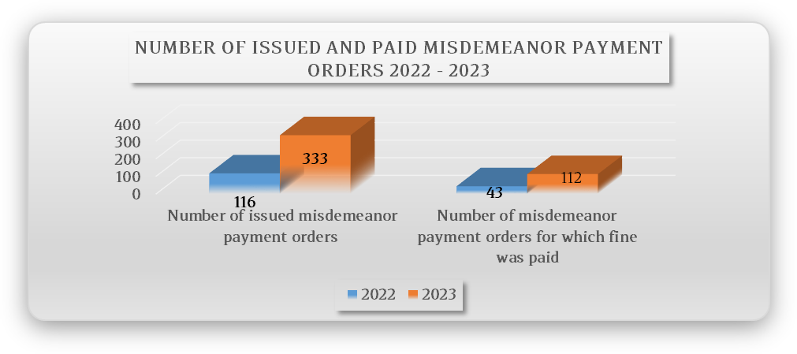
Figure 1 gives a comparative overview of the number of issued misdemeanor payment orders in 2023 compared to 2022, and the number of issued misdemeanor payment orders in 2023 compared to 2022, when the perpetrator paid the fine. As shown, number of issued misdemeanor payment orders and number of misdemeanor payment orders when the perpetrator paid the fine in 2023, compared to 2022, significantly increased. Number of misdemeanor payment orders issued in 2023 compared to the number of misdemeanor payment orders issued in 2022 increased by 187%, while number of misdemeanor payment orders issued in 2023, with the perpetrator having paid the fine, compared to the ones in 2022, surged by 160%.

Figure 2 - Comparative Overview of the Amount of Fines Pronounced and Paid under Settlement Procedures in 2022 and 2023
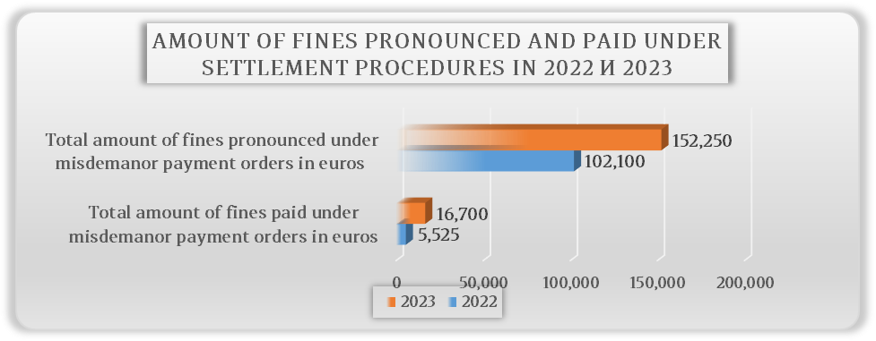

Figure 2 gives a comparative overview of the amount of fines pronounced and paid under settlement procedures in 2023 compared to 2022, clearly indicating the positive trend as regards the amount of fines pronounced and paid under the settlement procedure in 2023 compared to 2022. In fact, amount of pronounced fines under settlement procedures in 2023 compared to the amount of pronounced fines under settlement procedures in 2022 increased by 49%, while amount of paid fines under settlement procedures in 2023 surged by 202% compared to 2022.

Figure 3 – Taking actions upon reports for performing financial inspection in the period 2014-2023 s
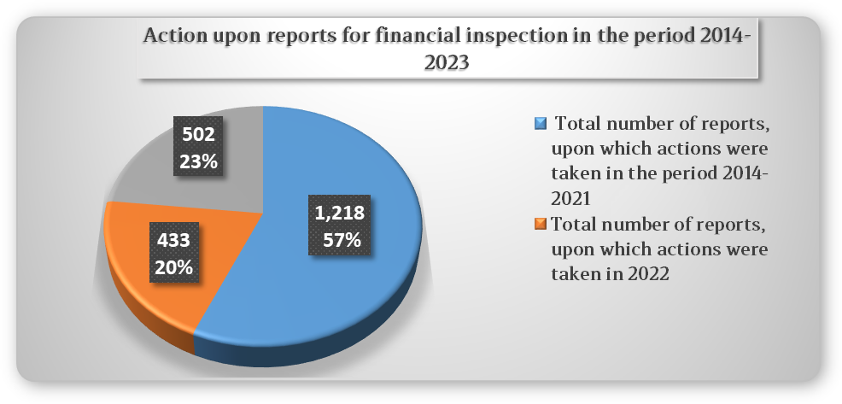
Total number of received reports on performed financial inspection amounted to Denar 13,464 in the period 2014 as of 2023 inclusive. Financial inspection in the period 2014 as of inclusive 2021 inclusive, took actions upon total of 1,218 reports, during 2022, actions were taken upon 433 reports, while taking actions upon 502 reports in the course of 2023. Within the performed financial inspections, inspection supervision was carried out pursuant to the Law on Financial Inspection in the Public Sector, and with respect to the observance of the provisions referred to in the Law on Accounting for Budgets and Budget Users, Law on Reporting and Recording Liabilities, Law on Financial Discipline, Law on Social Protection and Law on Culture.
Total positive trends the financial inspection recorded as regards the total actions taken in 2023, compared to the previous years, contributed to increased impact of the inspection in view of ensuring legality of the operations of public sector entities. This is coupled by the fact that as a result of the intensified inspections over public sector entities in relation to compliance with the provisions of the Law on Reporting and Recording Liabilities, starting December 2022 and throughout 2023, number of reports on performing financial inspection, filed due to non-compliance with the provisions of the mentioned Law, have recorded a downward trend. In fact, number of received reports on performing financial inspection upon this basis was 2,315 in 2022, while recording drastic and continuous reduction in 2023, i.e. 1,411 reports. This is one of the examples unambiguously pointing out to the effective impact the financial inspection produced in 2023 on the entities subject to financial inspection in view of attaining the primary goal to protect the public financial interests as regards the financial management of public funds and ensure legitimate operations and use of public funds.
III. Undertaken Measures Aimed at Improving the Institutional Setup of the Financial Inspection in the Public Sector Function
Under the Public Financial Management Reform Program “SMART PUBLIC FINANCES“ 2022 - 2025, Pillar VI - Public Internal Financial Control, Financial Inspection is indicated as Priority 3, aimed at professional development and strengthening of the financial inspection function as basis for increasing the quality of financial control in order to protect the public financial interests.
This priority’s objective will be achieved through two measures, as follows:
- strengthening the institutional basis of the financial inspection function, within which new Law on Financial Inspection in the Public Sector (*) (“Official Gazette of the Republic of North Macedonia”, no.19/23), which started applying as of 7th February 2023. Upon entry into force of the new Law, total of 17 bylaws and internal acts were prepared, 2 bylaws out of which were adopted and published in the “Official Gazette of the Republic of North Macedonia”, 4 internal acts were adopted and published on the website of the Ministry of Finance of the Republic of North Macedonia, with procedure for performing financial inspections with Annexes thereto, being prepared and submitted to the team in charge of quality, for consideration. Other bylaws and internal acts are undergoing final elaboration in more details, as well as harmonization with the Secretariat for Legislation.
Within IPA Twinning Project “Strengthening Budget Planning, Execution and Internal Control Functions”, Methodology for Gathering and Processing Statistical Data with Indicators for Monitoring, Measuring and Evaluating the Effectiveness of the Financial Inspection in the Public Sector was prepared with expert support.
- Financial inspection human resource capacities have been strengthened, which measure is realized with the support of the IPA Twinning Project “Strengthening Budget Planning, Execution and Internal Control Functions”, within the Training Program for Conducting Financial Inspection was prepared so as for the Department’s employees to acquire the necessary expertise and skills to identify, detect and, later on, act upon detected irregularities or suspicion of a criminal deed in budget management, thus contributing to strengthened financial discipline and safeguarding of the national financial interests.
At the same time, in line with the new Rulebooks on Organization and Systematization of Working Positions within Ministry of Finance, in the course of 2023, procedure for promoting 4 (four) employees in the Department was realized, while also initiating procedure for promoting another one (1) employee within the Department.
Public Finance Academy Department within the Ministry of Finance, established under the new Rulebook on Internal Organization and Operations of the Ministry, will carry out continuous professional development and vocational training of financial inspectors in performing financial inspection, as well as obtaining license for financial inspector and conducting an exam for obtaining a license for financial inspector.
To the end of ameliorating the required expert knowledge and skills, within Twinning Project “Strengthening Budget Planning, Execution and Internal Control Functions”, following activities have been implemented to the end of strengthening the financial inspection capacities, as follows:
- training was held – Criminal Code, Law on Criminal Procedure and other respective laws related to the legal practice on protection of the EU financial interests;
- workshop for budget accounting for inspectors was held and
- study visit in Prague - Czech Republic was realized.
To the end of improving the implementation of the activities and achieving the planned result, activities are being undertaken to finalize the procedure for introducing a system of annual remuneration of the financial inspectors based on the performance, through the elaboration of the Instruction on the method of monitoring, measuring and assessing the effectiveness of the inspectors, as a basis for awarding the prize for the best inspector according to legally set criteria and awarding the prize for the best financial inspector for 2024, promotion of employees in the financial inspection, as well as realization of new employments in the financial inspection and continuous professional development of the employees in the Department through trainings conducted by domestic and foreign trainers.

New Law on Financial Inspection in the Public Sector (*) (“Official Gazette of the Republic of North Macedonia”, no.19/23) entered into force on 7th February 2023.
As for the financial inspections commenced until the day of entry into force of the new Law on Financial Inspection in the Public Sector (*) (“Official Gazette of the Republic of North Macedonia“, no.19/23) , 7th February 2023, as per the provisions referred to in the new Law on Financial Inspection (“Official Gazette of the Republic of Macedonia”, nos. 187/13, 201/124, 215/15 and “Official Gazette of the Republic of North Macedonia”, nos. 124/19, 122/21 and 129/23), minutes from carried out inspection supervision was produced. As for the remining procedure for performing financial inspection pursuant to old Law on Financial Inspection in the Public Sector (“Official Gazette of the Republic of Macedonia”, nos. 82/13, 43/14, 153/15, 164/18 and “Official Gazette of the Republic of Macedonia”, no. 122/21), report on performed financial inspection was prepared. As regards financial inspections commenced from the day of the entry into force of the new Law on Financial Inspection in the Public Sector (*) (“Official Gazette of the Republic of North Macedonia“, no/19/23), 7th February 2023, prior and final minutes on performed financial inspection is produced.
As for committed misdemeanor stipulated in the Law on Financial Discipline (*) one request is submitted for initiating misdemeanor procedure for the public sector entity, as well as the person responsible with the public sector entity

